Docker Volume Persistence Automation using Jenkins on Azure

Objective

To design, implement, and automate a robust, declarative pipeline in Jenkins that centrally manages the lifecycle of Docker volumes, ensuring seamless data persistence, backup, and restoration for containerized applications.

# ssh -i <path> azureuser@<public ip address of VM> // using gitbash
Create Azure Account with Following Specifications

- Create a resource group for
- Standard D2s_v3 (2 vCPU, 8GB RAM, fast SSD)

Create a GitHub Repository

What this step achieves:
- Creates a central place to store your application
- Jenkins will pull code from this repo
- Your CI/CD pipeline begins with GitHub
- Steps :-
- Clone your repository in your vm with git bash
# git clone https://github.com/<your-username>/fastapi-postgres-ci-cd.git
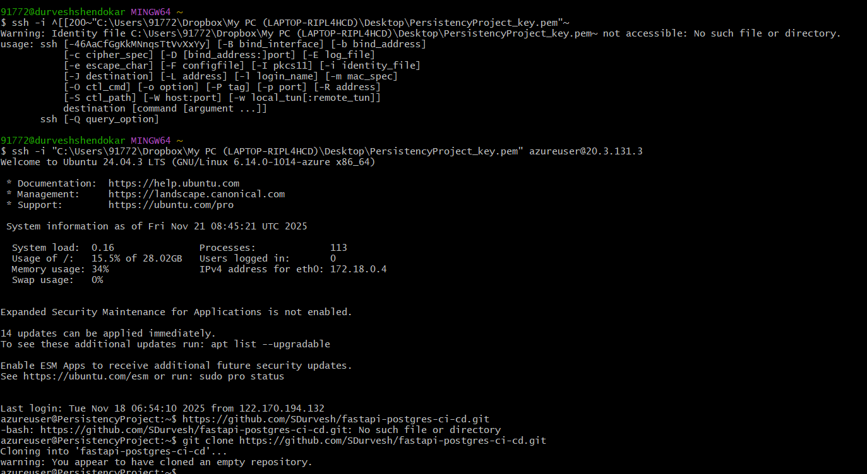
- Enter the folder and copy all files from our repo
# cd fastapi-postgres-ci-cd
# cp ~/fastapi-postgres-demo/app.py .
cp ~/fastapi-postgres-demo/requirements.txt .
cp ~/fastapi-postgres-demo/Dockerfile .
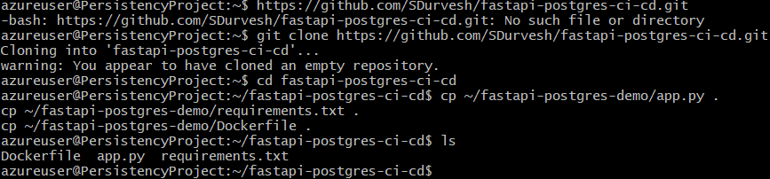
- Initialize Git and Push Code
# git remote remove origin
git remote add origin https://github.com/SDurvesh/fastapi-postgres.git
git push -u origin main
- Git will ask you user name and password for password create token (classic one) and paste it for password.
- Create a jenkins file for your project and add it in your folder
git add Jenkinsfile
git commit -m "Add Jenkins pipeline"
git push
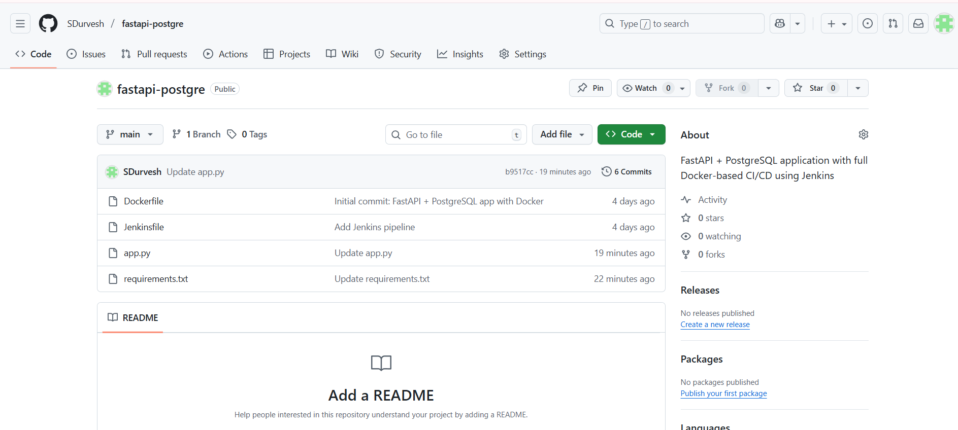for code:-
https://github.com/SDurvesh/fastapi-postgre.git
Installation process
Firstly allow required ports
SSH Terminal -- 22
Jenkins UI -- 8080
FastAPI -- 8000
PostgreSQL -- 5432
- Installing Docker
Update system
sudo apt update -y
sudo apt upgrade -y

Install Docker engine from Ubuntu’s repo
sudo apt install -y docker.io

Start Docker & enable on boot
sudo systemctl start docker
sudo systemctl enable docker

Verify Docker is running
docker --version

Install Jenkins on Ubuntu VM (Start here)
Run these commands:
Add Jenkins repo key
curl -fsSL https://pkg.jenkins.io/debian-stable/jenkins.io-2023.key | sudo tee \/usr/share/keyrings/jenkins-keyring.asc > /dev/null

Add Jenkins repo to sources
echo deb [signed-by=/usr/share/keyrings/jenkins-keyring.asc] \https://pkg.jenkins.io/debian-stable binary/ | sudo tee \/etc/apt/sources.list.d/jenkins.list > /dev/null
Update packages
sudo apt update
Install Java (required for Jenkins)
sudo apt install openjdk-17-jdk -y

Install Jenkins
sudo apt install jenkins -y

Enable and start Jenkins
sudo systemctl enable jenkins
sudo systemctl start jenkins
sudo systemctl status jenkins
You should see Active: running\
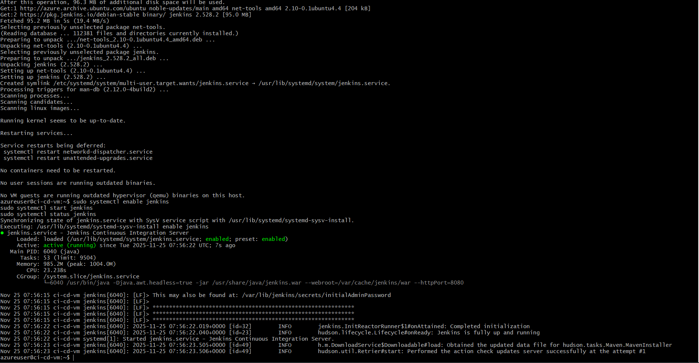
Opening an jenkins account for CICD preparation

Open Jenkins in Browser
http://<YOUR_VM_PUBLIC_IP>:8080
You should see the Unlock Jenkins screen.
- Get the Jenkins Initial Admin Password
Run this on your VM:
sudo cat /var/lib/jenkins/secrets/initialAdminPassword
Copy the password → paste it into the browser.
- Install suggest plugins and gave permissions and password
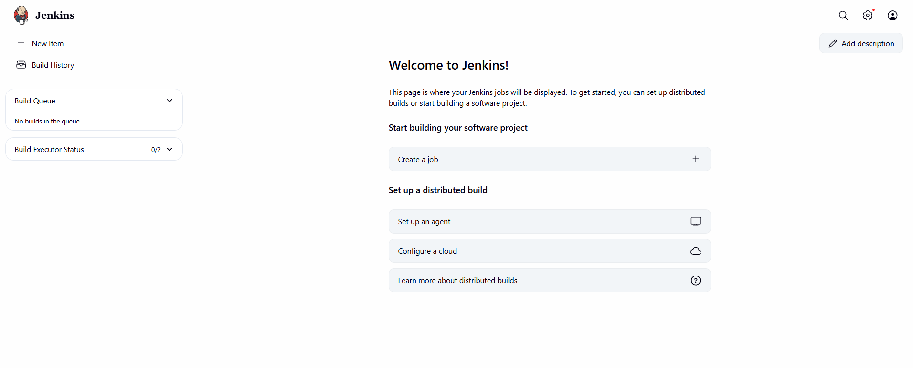

Give Jenkins Permission to Use Docker

Add Jenkins user to docker group
sudo usermod -aG docker jenkins

Restart Jenkins service
sudo systemctl restart jenkins

Restart Docker service

sudo systemctl restart docker

Verify Jenkins is in the docker group
groups jenkins
jenkins : jenkins docker

Give full permissions to Docker socket (temporary but safe for lab)
sudo chmod 666 /var/run/docker.sock

Test Docker from Jenkins user
Switch to Jenkins user: sudo su - jenkins
Then test:
docker ps
If you see a table (even empty), Jenkins now has correct Docker access.
Exit Jenkins user:
exit
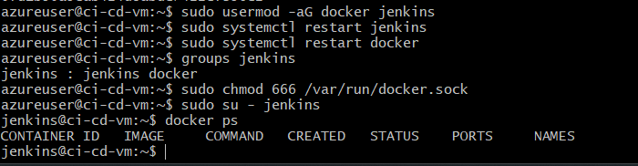
Create GitHub Fine-Grained Personal Access Token

1. Go to:
GitHub → Settings → Developer Settings → Personal access tokens → Fine-grained tokens

2. Click: “Generate new token”
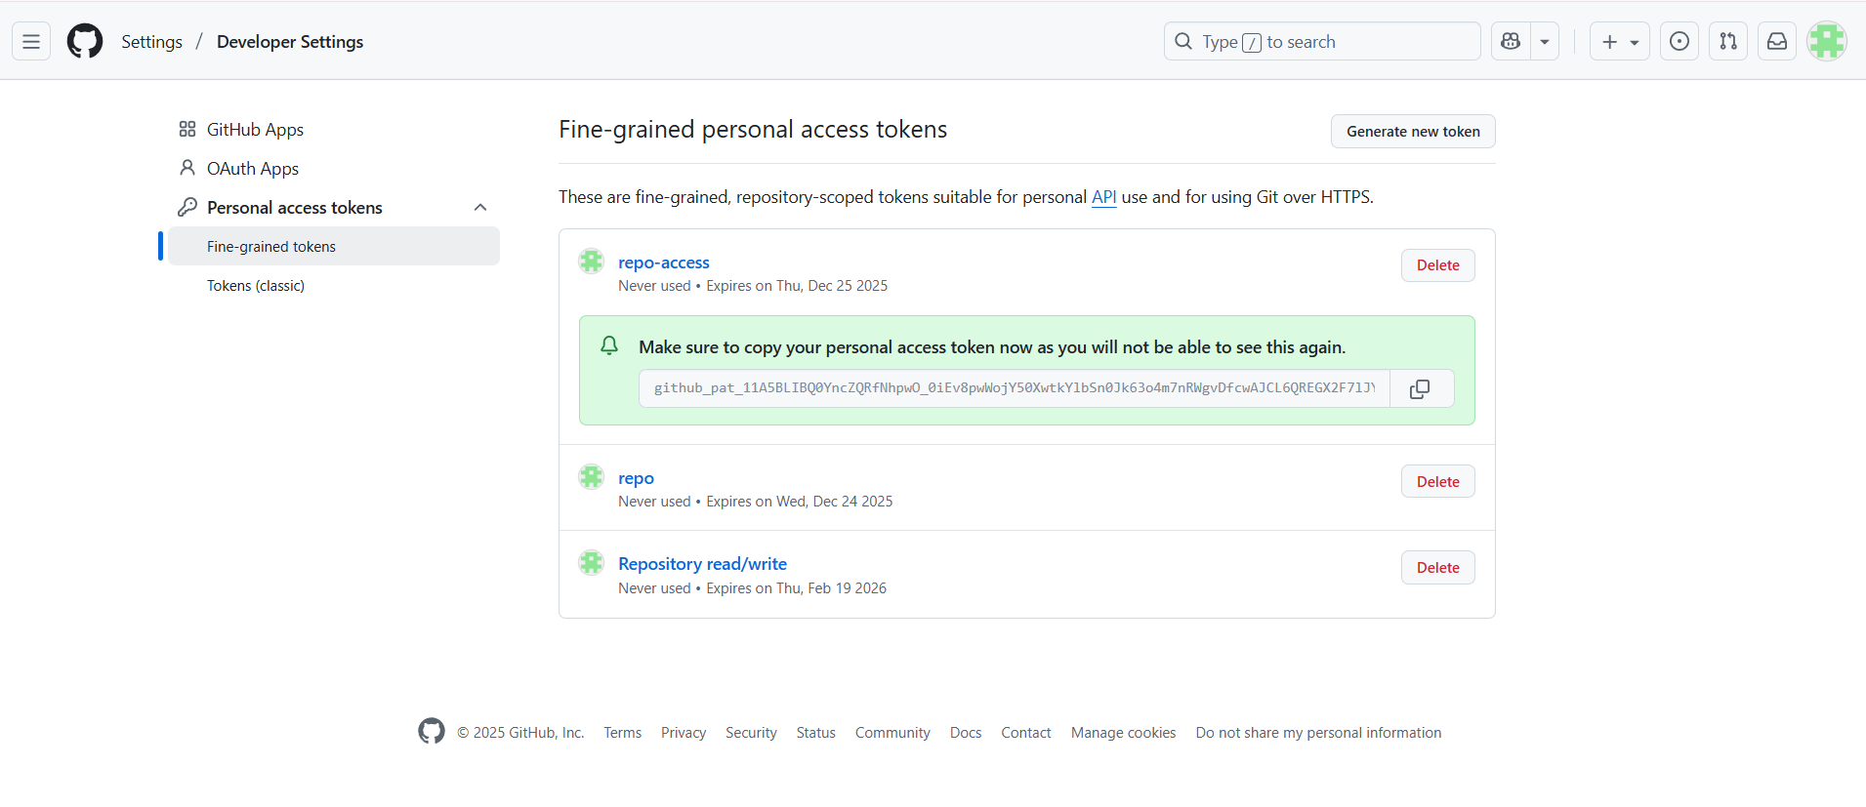

Add GitHub Token to Jenkins Credentials
Now that our GitHub fine-grained token is created, we must store it inside Jenkins so pipelines can pull your repo.

1. Open Jenkins
Visit: http://YOUR_VM_PUBLIC_IP:8080

2. Go to:
Dashboard → Manage Jenkins → Credentials

3. Select this store:
Stores scoped to Jenkins → System → Global credentials (unrestricted)

Fill the credential form exactly like this:

Kind: Secret text

Secret: Paste your GitHub token here.

ID: github-token

Description:
GitHub PAT for Jenkins
Install These Plugins
- Pipeline
- git/Github credentials
- Credentials
- Authentication credentials
- Docker
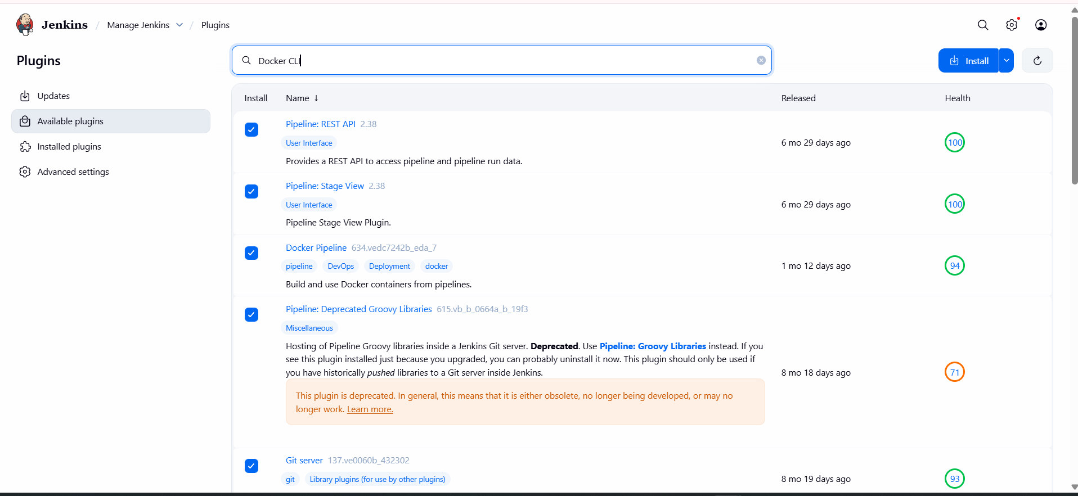
Create Jenkins Credential for GitHub Token

1. Go to Jenkins Credentials
In Jenkins UI:
Dashboard → Manage Jenkins → Credentials
On the left: System
Click Global credentials (unrestricted)
Click Add Credentials

2. Fill in credentials details

Choose:
Kind: Username with password
Username: your GitHub username
Password: → paste your GitHub PAT token
ID: github-creds
Description: GitHub PAT for CI/CD
Click Create

Create a New Jenkins Pipeline Job

Go to Jenkins Dashboard
Click New Item

Create Pipeline Job
Fill the details:
Enter an item name:
fastapi-postgres-ci-cd
Select Pipeline
Click OK

3. Configure the Pipeline
Scroll down to Pipeline section and set:

Definition: Pipeline script from SCM

SCM: Git

Repository URL:
https://github.com/SDurvesh/fastapi-postgres-ci-cd.git

Credentials:
Select the one you created:
github-creds

Branch:*/main

Script Path: Jenkinsfile

Save
Your pipeline is now connected to GitHub.

5. Run First Build
On the project page:
Click Build Now
You should see Jenkins:
- Cloning repository
- Running pipeline
- Building Docker image
- Running PostgreSQL
- Deploying app
- Running health checks
